**Course REQUEST Verifications Instructions**

**Cypress Falls High School – 9th - 11th Grade**

**2020-2021 Course Verification Quick Reference Guide**

Parents/guardians and students currently have the opportunity to review the student’s course selections for the 2020-2021 school year online using their Home Access Center account. Access will be available from **Monday, May 4, 2020 through Tuesday, May 12, 2020.**

Please review the steps below for instructions on how to log in to the Home Access Center, and where to find your student’s current list of course requests for the 2020-2021 school year.

After logging in to view your student’s current list of REQUESTED courses, please follow directions to request changes to those courses.

***Step 1: Access the Home Access Center – to view student course requests***

If you need help accessing the Home Access Center, click here.

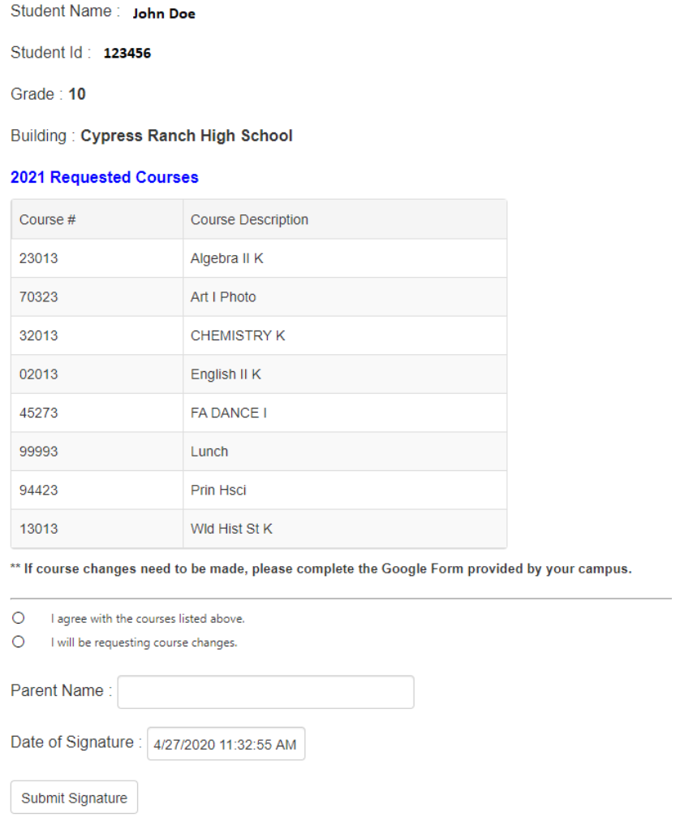When you log in to HAC, click the tab for Requests.

All pre-loaded courses will be visible on this screen as shown on this example:

You will not be able to edit these choices in HAC; however, you will be able to review the courses your student currently has listed as requests for the 2020-21 school year. The selections must include enough courses to fill the full, seven (7) period school day.

Indicate “Agree” or “Requesting changes”

Note: classes that end in 3 = full year; classes that end in 0 = half year classes.

***Step 2: Reviewing your student’s course requests***

This is not a schedule; it is a list of requested courses. **If the courses are correct, you will indicate so in HAC, and no further action is needed.**

**If a change is needed, please read all instructions carefully before completing the Google Link.**

This form will be completed for any student who is requesting a change to his/her course requests for the 2020-2021 school year by **Tuesday, May 12, 2020**.

**This is the priority deadline for making changes to 2020-21 course requests.**

* **Please check for 7 classes.** If any classes are missing, write them in on the Google form and include the level (academic or K/AP), if necessary.
  + You can review detailed course information in the 2020-21 Course Catalog, using this link: <https://www.cfisd.net/download_file/view/28644/1523> (HS)
  + In order to fulfill graduation requirements of Foundations with Endorsement, students should consider completing courses to meet the graduation requirements. To view the graduation plan, click here.
* **To meet the priority deadline, request course changes at this time. Please review and consider all courses carefully.** Sometimes student requests may exceed available seats, and alternate choices will be used.
* **NOTE**- Students may be placed in an intervention class in lieu of their elective (and/or PE) depending on their previous year’s performance, as determined by campus administration.

[*Course Verification Change Request Form*](https://docs.google.com/forms/d/e/1FAIpQLSczKTLrUCKSfdseOnaMh5kC0r80dFF4rBXBDZwmPCo2yPwXpQ/viewform?usp=sf_linkhttps://docs.google.com/forms/d/e/1FAIpQLSczKTLrUCKSfdseOnaMh5kC0r80dFF4rBXBDZwmPCo2yPwXpQ/viewform?usp=sf_linkhttps://docs.google.com/forms/d/1UQEFEC6A3B35DQIeyc-P1QlRyzqO93isIAIZGiVh27c/edit) *– click on the link below to make changes:*

[**https://docs.google.com/forms/d/e/1FAIpQLSczKTLrUCKSfdseOnaMh5kC0r80dFF4rBXBDZwmPCo2yPwXpQ/viewform?usp=sf_link**](https://docs.google.com/forms/d/e/1FAIpQLSczKTLrUCKSfdseOnaMh5kC0r80dFF4rBXBDZwmPCo2yPwXpQ/viewform?usp=sf_link)

HAVE YOU MOVED? ARE YOU MOVING OVER THE SUMMER?

IF SO, PLEASE CONTACT OUR CAMPUS REGISTRAR

Remember that a current proof of residence is required to be on file at all times. This is the responsibility of the parent to verify that your information is correct for your student as important information will be mailed over the summer.

**Instructions to Access the Home Access Center**

Access the Cypress-Fairbanks ISD website at [www.cfisd.net](http://www.cfisd.net)

Find and select the Home Access Center to the right corner of your screen and click Sign in:



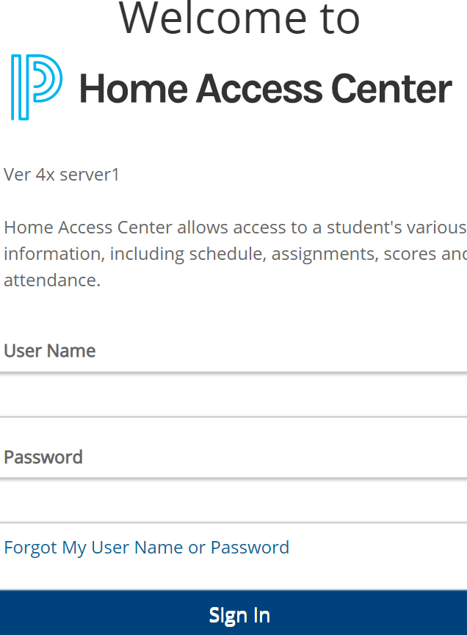You will then need to click on the Home Access Center button on the subsequent page:

Parents/guardians and/or students may then log in to the HAC by entering their specific Username and Password and then clicking on the Login button.

If you do not remember your Login credentials, please first try to recover that information using the “Forgot My Username or Password” link at the bottom of the page. If you and/or your student are still having issues, then please contact:

Stacy Bankhead at [stacy.bankhead@cfisd.net](mailto:stacy.bankhead@cfisd.net) or call 281-856-1000.

**Reviewing Course Requests through Guardian’s HAC**

Once you are in the Home Access Center, click on the **Home** icon in the menu bar at the top:



Next, select the ***School Links*** tab, followed by **Course Confirmation**: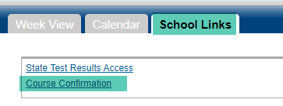

**Graduation Requirements for the Classes of 2018 and Beyond**

Students who enter the ninth grade in the fall of 2014 and thereafter must enroll in courses necessary to complete the Foundation High School Program with an endorsement. Students may also earn Distinguished Level of Achievement by including and successfully completing Algebra II in their selected coursework. Students should study the table below which outlines requirements for 22 credits for the Foundation High School Program plus the 4 additional credits required for an endorsement. Counselors at each high school will furnish details associated with endorsements and other information necessary for student to complete registration.

|  |  |  |  |
| --- | --- | --- | --- |
| **Course** | **Foundation** | **+Endorsement** | **Notes** |
| English | 4 |  | * English I, II and III are required with options for the 4th credit. |
| PACE  (Personal, Academic, & Career Exploration)  or  PACE Plus | 1/2 or 1 |  | * One-half credit is required in grade 9. * One credit is required for 9th-grade students who did not pass all 8th grade core academic classes (language arts, reading, math, science, and social studies) and who have not met the state standards on any 8th grade STAAR assessment. * *The state required speech TEKS are embedded in PACE and PACE Plus.* |
| Mathematics | 3  Algebra I,  Geometry, and an  additional math course | + 1 additional advanced math course | * Algebra II must be taken to earn the Distinguished Level of Achievement.   NOTE: State graduation requirements do not mandate that a student complete Algebra II to graduate under the Foundation High School Program. If a student does not  complete an Algebra II course, the student will not be eligible for automatic college admission or certain financial aid including the TEXAS Grant Program and the Texas Educational Opportunity Grant Program. |
| Science | 3  Biology  and  IPC, Chemistry, or Physics, and an additional science course | +1 additional advanced science course | * Biology is required for all students. |
| Social Studies | 3  World Geography or World History, U.S. History, Government (1/2) & Economic (1/2) |  | * Students may substitute AP Human Geography for World Geography but may not earn credit for both courses. |
| Languages other than English (Foreign Language) | 2 |  | * Students take and earn two credits in the same language |
| Health | 1/2 |  | * Health may be taken in any grade or through correspondence, summer school, or credit-by-exam. * Principles of Health Science satisfies the health requirement. |
| Physical Education | 1 |  | * Students may earn a maximum of four (4) credits in PE toward graduation-including athletics. * Students may meet the PE requirement through after school participation in the fall semester of marching band and cheerleading, and both semesters of drill team and AFJROTC. Students may also meet the PE requirement if they participate in a district-approved Olympic caliber, off-campus training program. * PE credit may be earned through approved correspondence courses. |
| Fine Arts | 1 |  | * Approved fine arts courses include art, music, dance, theatre courses and floral design. * Students must take 2 sequential semesters of the same course to meet the Fine Arts credit requirement. |
| Electives | 4 | + 2 additional electives |  |
| **Total Credits Required** | **22** | **26** |  |

Cypress-Fairbanks ISD - The Endorsements

A student must complete the Foundation High School Program (22 credits), one additional math credit, one additional science credit, and two additional elective credits while

completing the specific requirements of his/her selected endorsement.

|  |  |  |  |  |
| --- | --- | --- | --- | --- |
| **STEM**  *Science, Technology, Engineering, & Math* | **Business & Industry** | **Public Services** | **Arts & Humanities** | **Multidisciplinary Studies** |
| Students may earn a STEM endorsement by selecting and completing the requirements from among these 5 options. | Students may earn a Business & Industry endorsement by selecting and completing the requirements from among these **3** options. | Students may earn a Public Services endorsement by selecting and completing the requirements from among these **2** options. | Students may earn an Arts & Humanities endorsement by selecting and completing the requirements from among these **3** options. | Students may earn a Multidisciplinary Studies endorsement by selecting and completing the requirements from among these **2** options. |
| **Note:** Algebra II, Chemisty, and  Physics are required for the STEM endorsement regardless of the option the student selects from below.  **Option 1: Computer Science**  **(Technology)**  Students take 4 computer science courses.   * Computer Science 1 K * Computer Science Principles AP * Computer Science II K * Computer Science III K * Project-based Research in Computer Science K   **Option 2: CTE (Engineering)** Students earn four (4) CTE credits by taking at least two (2) courses in the  same cluster that lead to a final course in the STEM cluster.  At least one (1) of the courses must be advanced CTE course (3rd year or higher course in a sequence).  **Option 3: Math**  Students take Algebra I, Geometry, and Algebra II AND two (2) of the following courses for which Algebra II is a prerequisite.   * Pre-Calculus * Calculus AB or BC * Statistics AP * AQR K * Advanced Algebra * College Algebra K | **Option 1: CTE**  Students earn four (4) credits by taking at least two (2) courses in the same cluster in one of the following areas   * Agriculture, Food and Natural Resources * Architecture and Construction * Arts, Audio/Video Technology, and Communication * Business, Marketing and Finance * Hospitality and Tourism * Information Technology * Manufacturing * Transportatation, Distribution, and Logistics   with at least one (1) advanced (3rd year or higher course in the sequence).  **Option 2: English**  Students take four (4) English elective credits that include three levels in one of the following areas   * Advanced Journalism: Newspaper or Yearbook * Debate   **Option 3: Combination**  Students take a coherent sequence of four (4) credits from Option 1 and  2. Combination plan must include one (1) advanced CTE course. | **Option 1: CTE**  Students earn four (4) credits by taking at least two (2) courses in the same career cluster in one of the following areas   * Education and Training * Health Science * Human Services   With a least one (1) advanced (3rd year or higher course in the sequence).  **Option 2: AFJROTC**  Student takes four (4) AFJROTC courses for (4) credits | **Option 1: Social Studies** Students should earn five (5) social studies credits.  **Option 2: Languages Other Than English (Foreign Language)** Students take four (4) levels of the same foreign language.  OR  Students take two (2) levels of one foreign language AND two (2) levels of a different foreign language  (two levels in each of two different foreign languages for 4 credits).  **Option 3: Fine Arts**  Students take four (4) courses in the same fine arts area for 4 credits  OR  Students take two (2) courses in one fine arts area AND two (2) courses in a different fine arts area (two courses in each of two different fine arts areas for 4 credits). | **Option 1: Four by Four (4 X 4)** Students take four (4) courses in each of the four core content areas.   * Four (4) English credits including English IV * Four (4) math credits * Four (4) science credits including biology and chemistry and/or physics * Four (4) social studies credits   **Option 2: AP / Dual**  Students take four (4) Advanced Placement (AP) or four (4) Dual Credit courses for four (4) credits in English, math, science, social studies, foreign language, or fine arts.  OR  Students take a combination of Advanced Placement (AP) or Dual credit courses for four (4) credits in English, math, science, social studies, foreign language, or fine arts. |