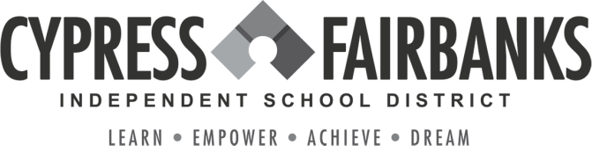

To: 8th Grade Parents/Guardian

RE: 8th Grade Guidance Program 2023
From: Cypress-Fairbanks ISD
In an effort to support students as they plan for their future, we will implement a Guidance Program this fall that will allow 8th grade students to explore their abilities, career interests, and academic options.

The program is designed to introduce students to the Texas high school graduation plan (Foundation High School Program + Endorsement), explore career options and programs of study related to each endorsement, and create a 4-Year Plan for high school that will support their college and career goals.

Program Components:
- In-depth exploration of each endorsement area, programs of study, and related careers
- Course requirements for graduation
- Assessment to measure interests and abilities
o Xello – “Matchmaker” and “Learning Styles”
- Course selection for 9th grade and development of a 4-Year Plan for high school
- Parent meeting to review student plans District Activities:
- College Week and Generation Texas Month – October/November
- “Keeping the Options Open” (8th to 9th grade informational meeting for parents) – TBD

Helpful Resources for Parents:
- 8th Grade Guidance Program – Student Booklet
  - www.cfisd.net
    - Parents & Students
      - Counseling
        - Secondary Guidance Program
          - 8th Grade Guidance Program
- Xello
  - www.my.cfisd.net
    - Additional Resources
      - Xello SSO Student Access

- High School Course Description Guide
  - www.cfisd.net
    - Academics
      - Curriculum & Course Descriptions

We hope you will encourage your student to make the most of this opportunity to explore and plan for his/her future.

